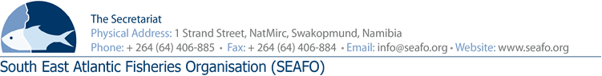

LIST OF DOCUMENTS FOR THE 11TH ANNUAL MEETING OF THE COMPLIANCE COMMITTEE (CC) - 2018

CHAIR: Mr. L Molledo (EU) Venue: Strand Hotel, Swakopmund
VICE-CHAIR: Mr. Ryo Omori (JAPAN) Date: 27 November 2018

Document Ref. Number | Agenda Item | Document Title | Provider | Availability of Document
DOC/CC/00/2018 |  | List of Documents | Secretariat | Available before meeting
DOC/CC/01/2018 | All | Provisional agenda for the 11th Annual Meeting of the Compliance Committee | Secretariat | Available before meeting
DOC/CC/02/2018 | All | Provisional Annotated agenda for the 11th Annual Meeting of the Compliance Committee | Secretariat | Available before meeting
DOC/CC/03/2018 | 6 | Executive Secretary’s Report on Compliance | Secretariat | Available before meeting
DOC/CC/04/2018 | 7 | SEAFO “SYSTEM 2017” | Secretariat | Available before meeting
DOC/CC/05/2018 | 8 | SEAFO provisional IUU Vessel list 2018 | Secretariat | Available before meeting
DOC/CC/06/2018 | 8 | Cape Flower Correspondence | Secretariat | Available before meeting

Circulation Date: 27 October 2018

